

**United Kingdom Road Accidents Analysis**

ALY6010 Data Management and Big data

Spring 2019

Submitted on: May 13, 2019

Submitted by:

ANUJ SANJAY GOLESAR

DISHALI SONAWANE

**Instructor: Prof. SERGIY SHEVCHENKO**

INTRODUCTION

The UK government collects and publishes (usually on an annual basis) detailed information about traffic accidents across the country. This information includes, but is not limited to, geographical locations, weather conditions, type of vehicles, number of casualties and vehicle manoeuvres, making this a very interesting and comprehensive dataset for analysis and research.

In this project we have focused on deriving the insights which will be useful for local authorities such as Patrolling police and Emergency medical services to avoid the accidents and alert the drivers and pedestrians . This project helps to understand the usage and implementation of the Big Data tool such as Microsoft Azure and Jupyter notebook , Apache Spark and so on.

For this project we have selected two datasets. First is holds records of around 2.08mn unique accidents and second one which holds information about vehicles, accidents causes , road conditions , vehicle brand name etc.

The creation of this dataset was inspired by the one previously published by [Dave Fisher-Hickey](https://www.kaggle.com/daveianhickey/2000-16-traffic-flow-england-scotland-wales). However, this current dataset features the following significant improvements over its predecessor:

* It covers a wider date range of events.
* Most of the coded data variables have been transformed to textual strings using relevant lookup tables, enabling more efficient and "human-readable" analysis.
* It features detailed information about the vehicles involved in the accidents.

PROCEDURE :

Click on the link <https://azure.microsoft.com/en-us/solutions/data-warehouse/>

Click on the Free Account in top right corner.



Click on start free trial



Sign in with your university id

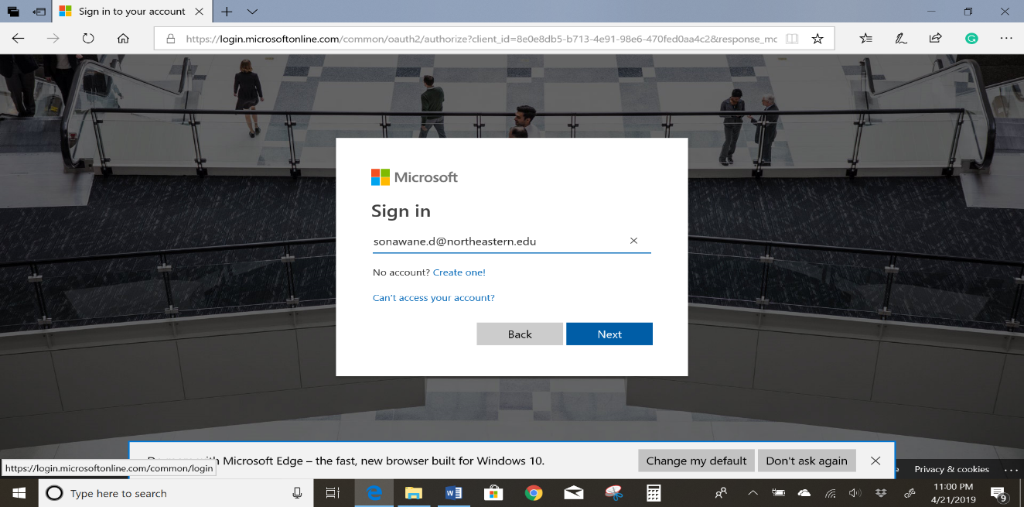

Enter your password.

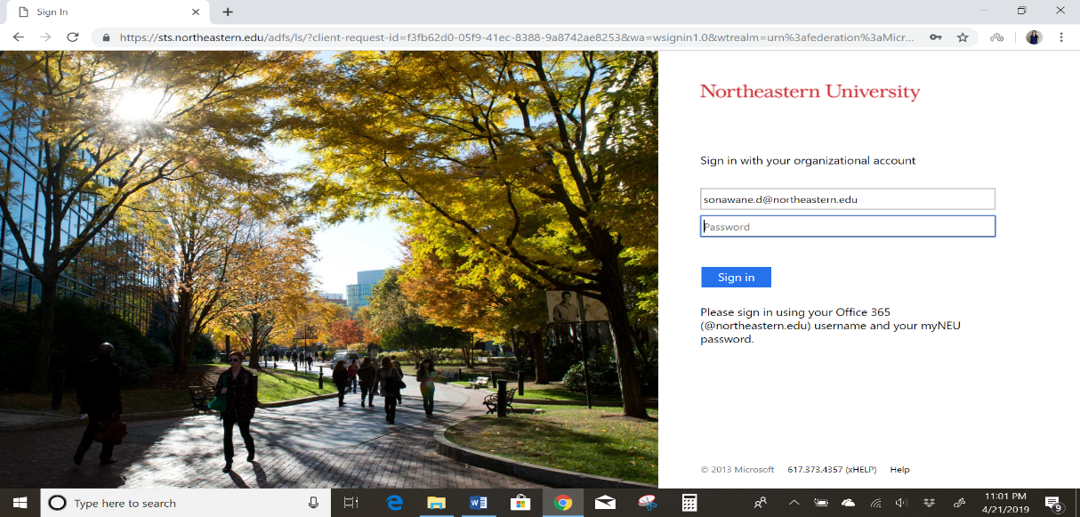

Fill in the required information and click next.

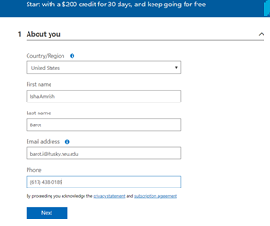

Click on the agreement box and sign in to complete.

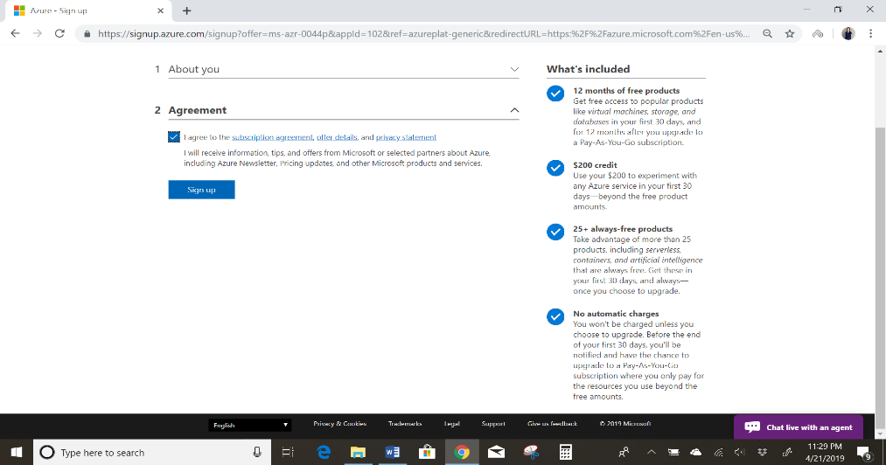

Now you are all set with your Microsoft Azure account.



Once the Deployment is ready

Go to dashboard and you can see the deployment name 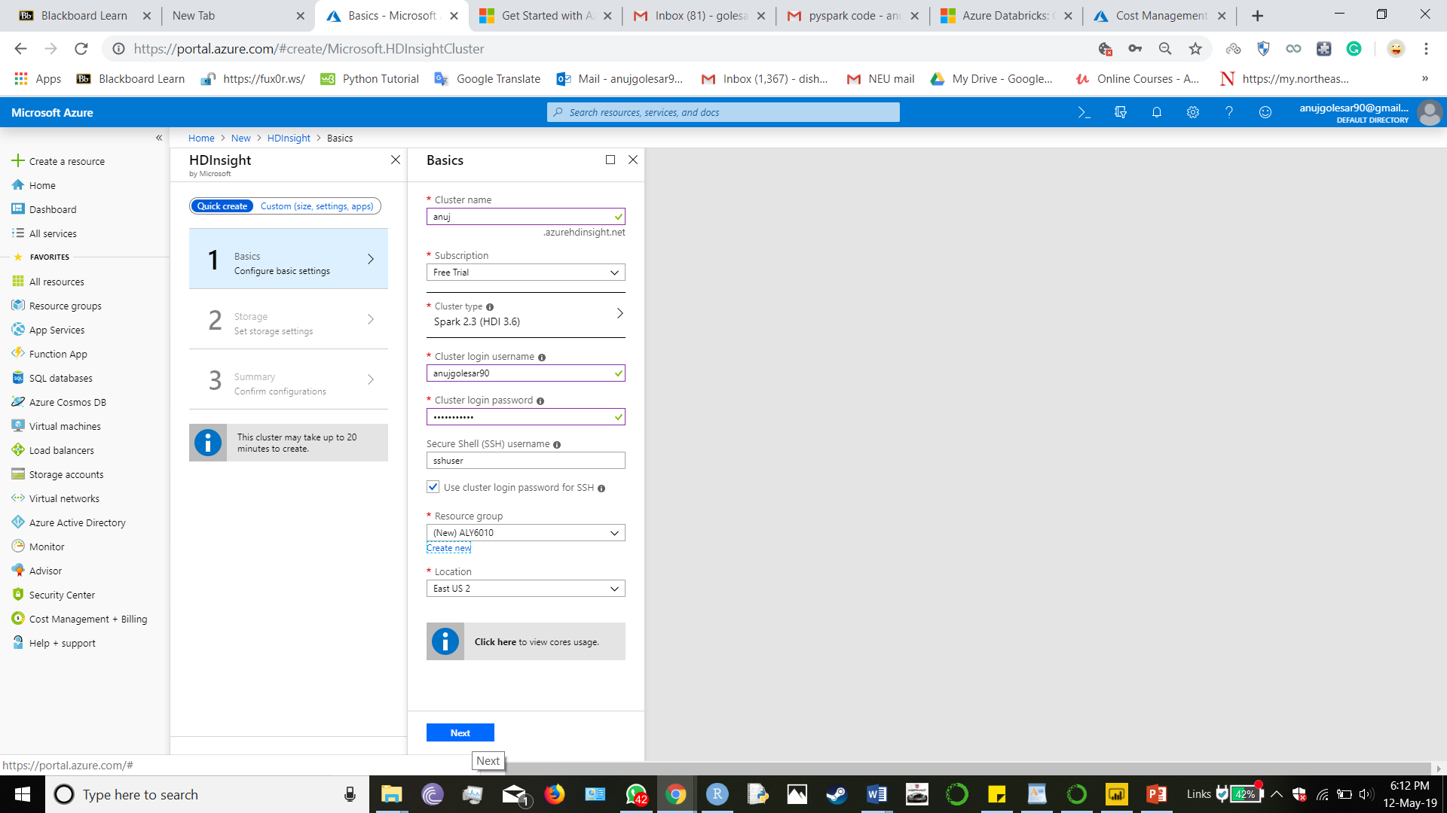

This snap shot illustrates the HDinsights cluster is activate.

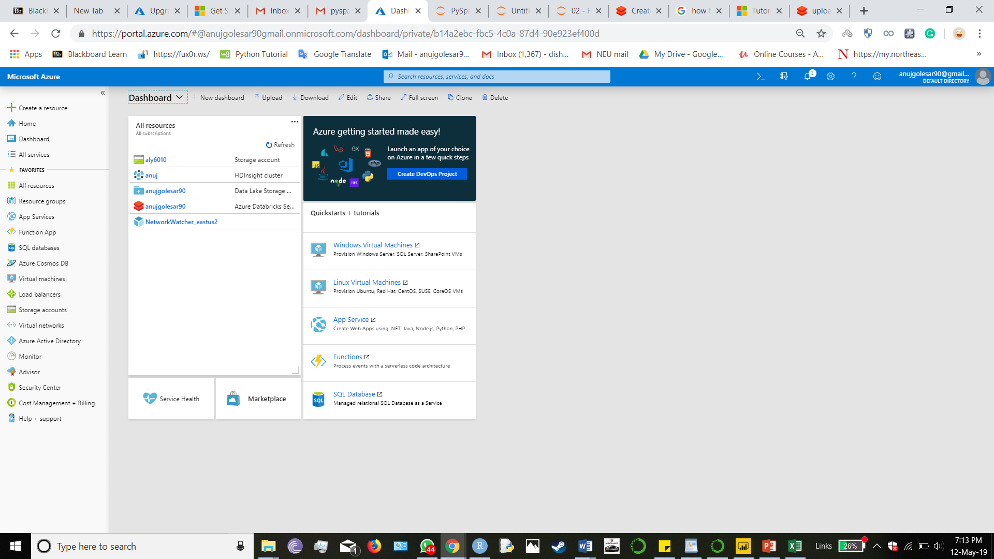

Upload the csv file to blob , select on blob storage account

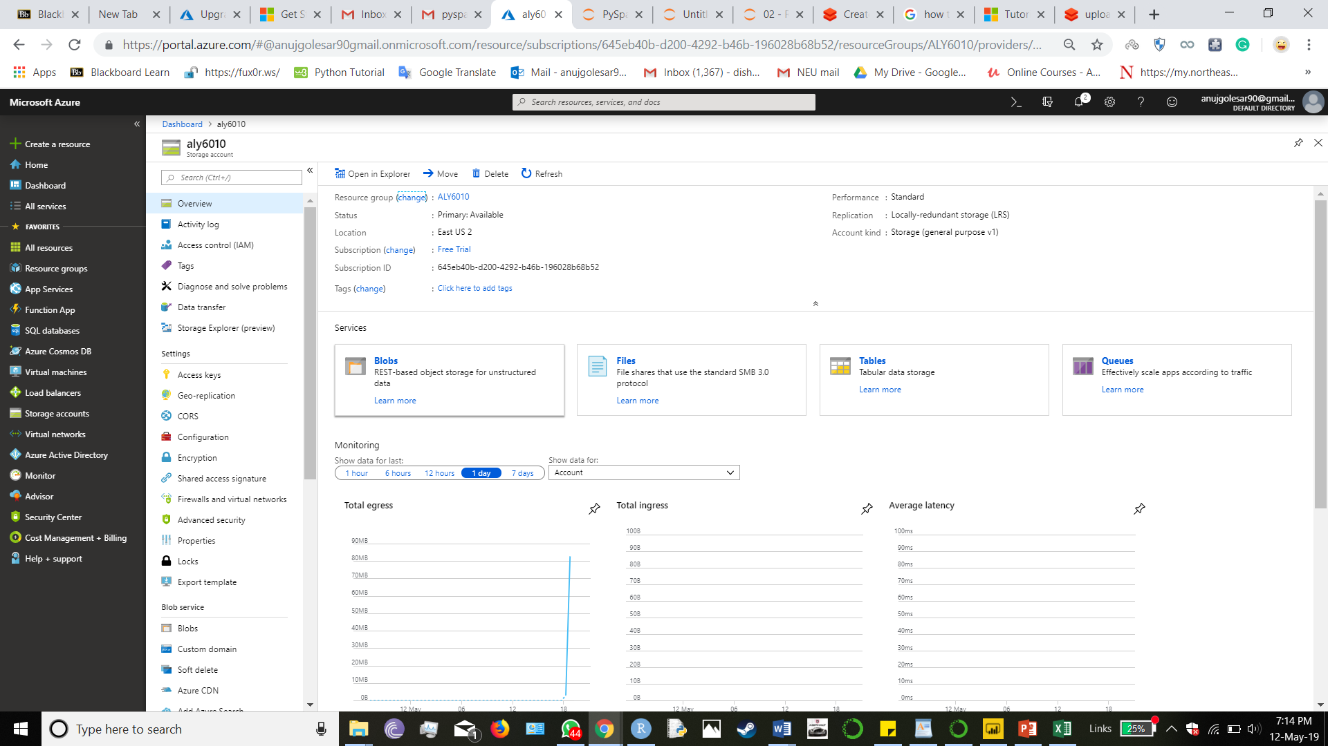

Click on Blobs , it will show the name of the storage

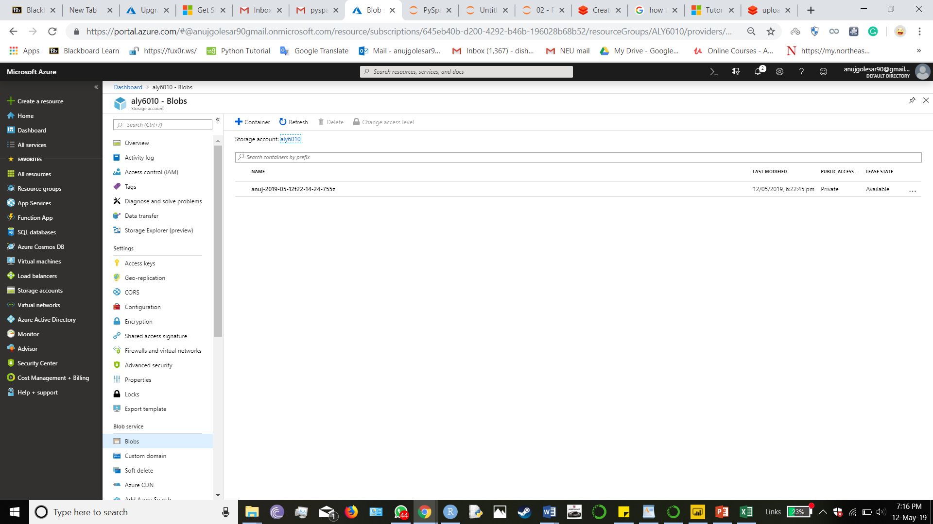

Further navigate to the folder where we must upload the csv files

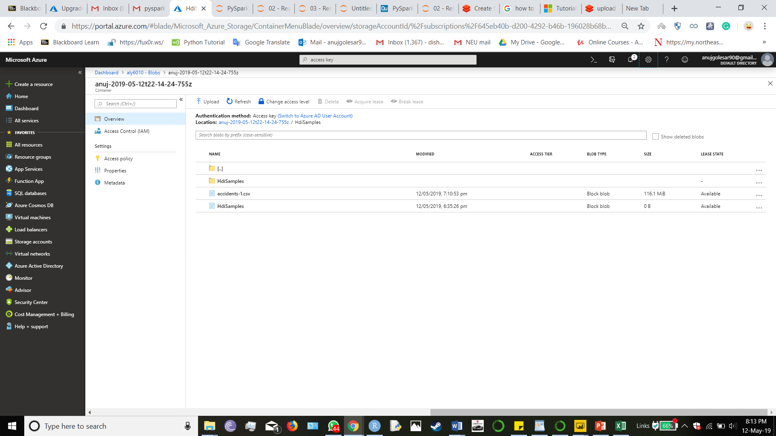

Click on upload to upload files

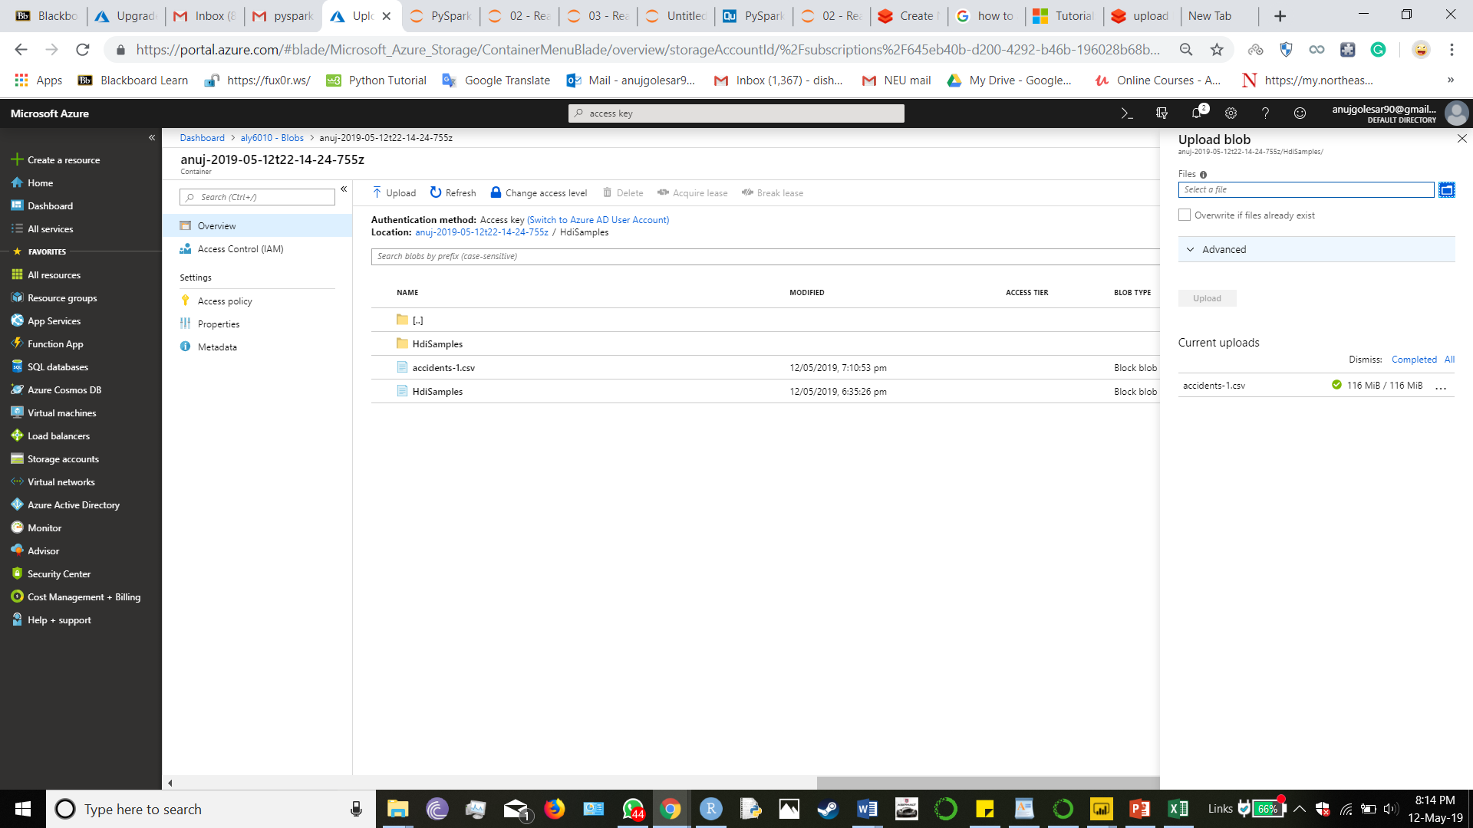

Browse the files from local disk

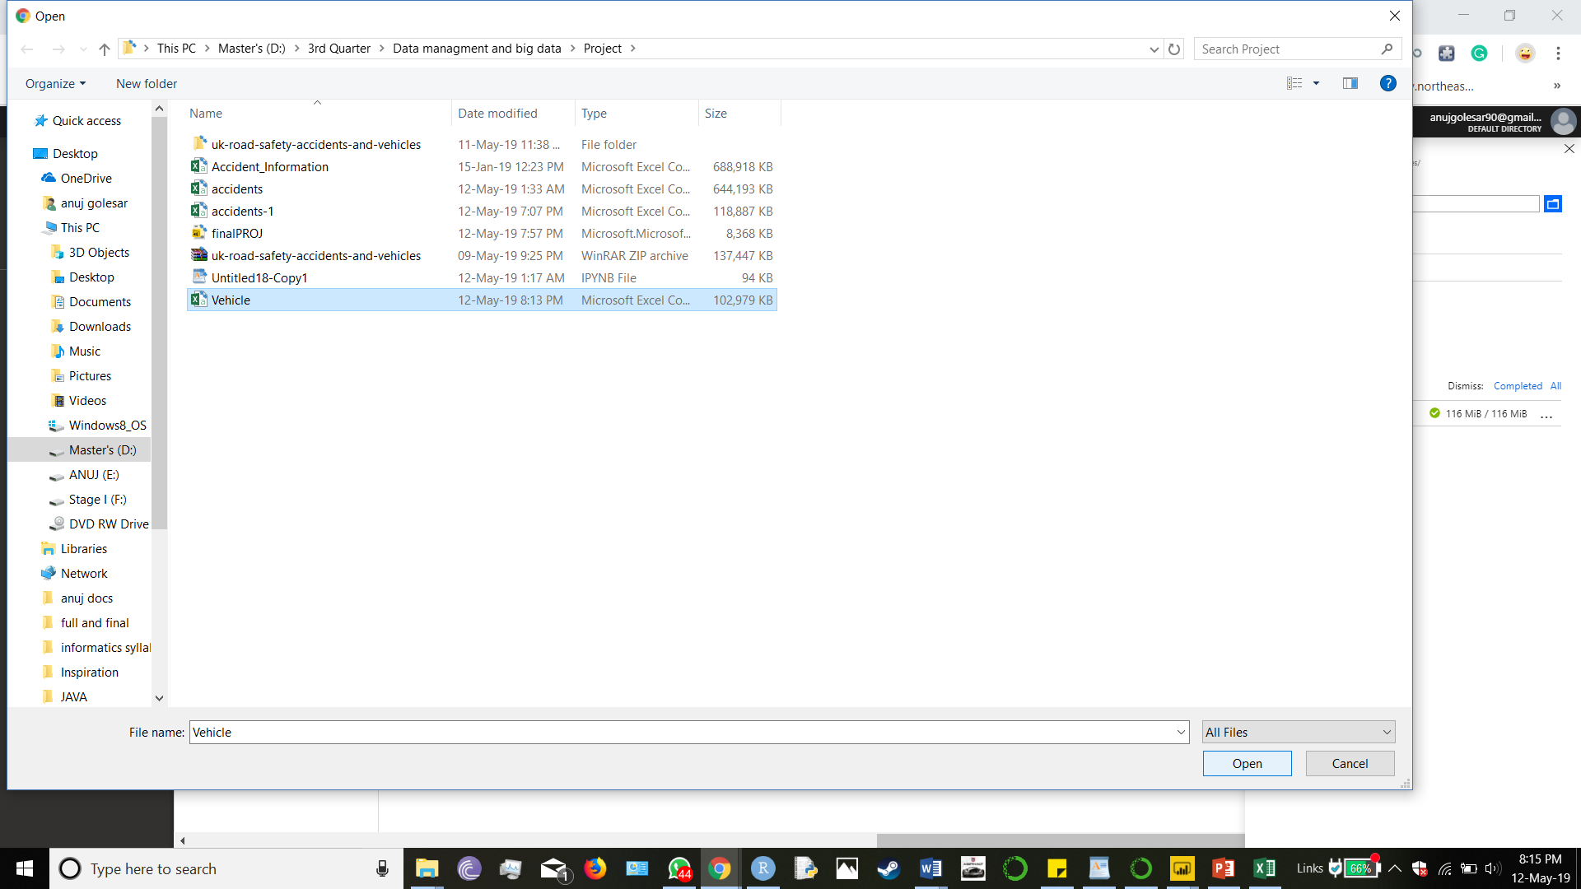

Now we have uploaded the files to clean :

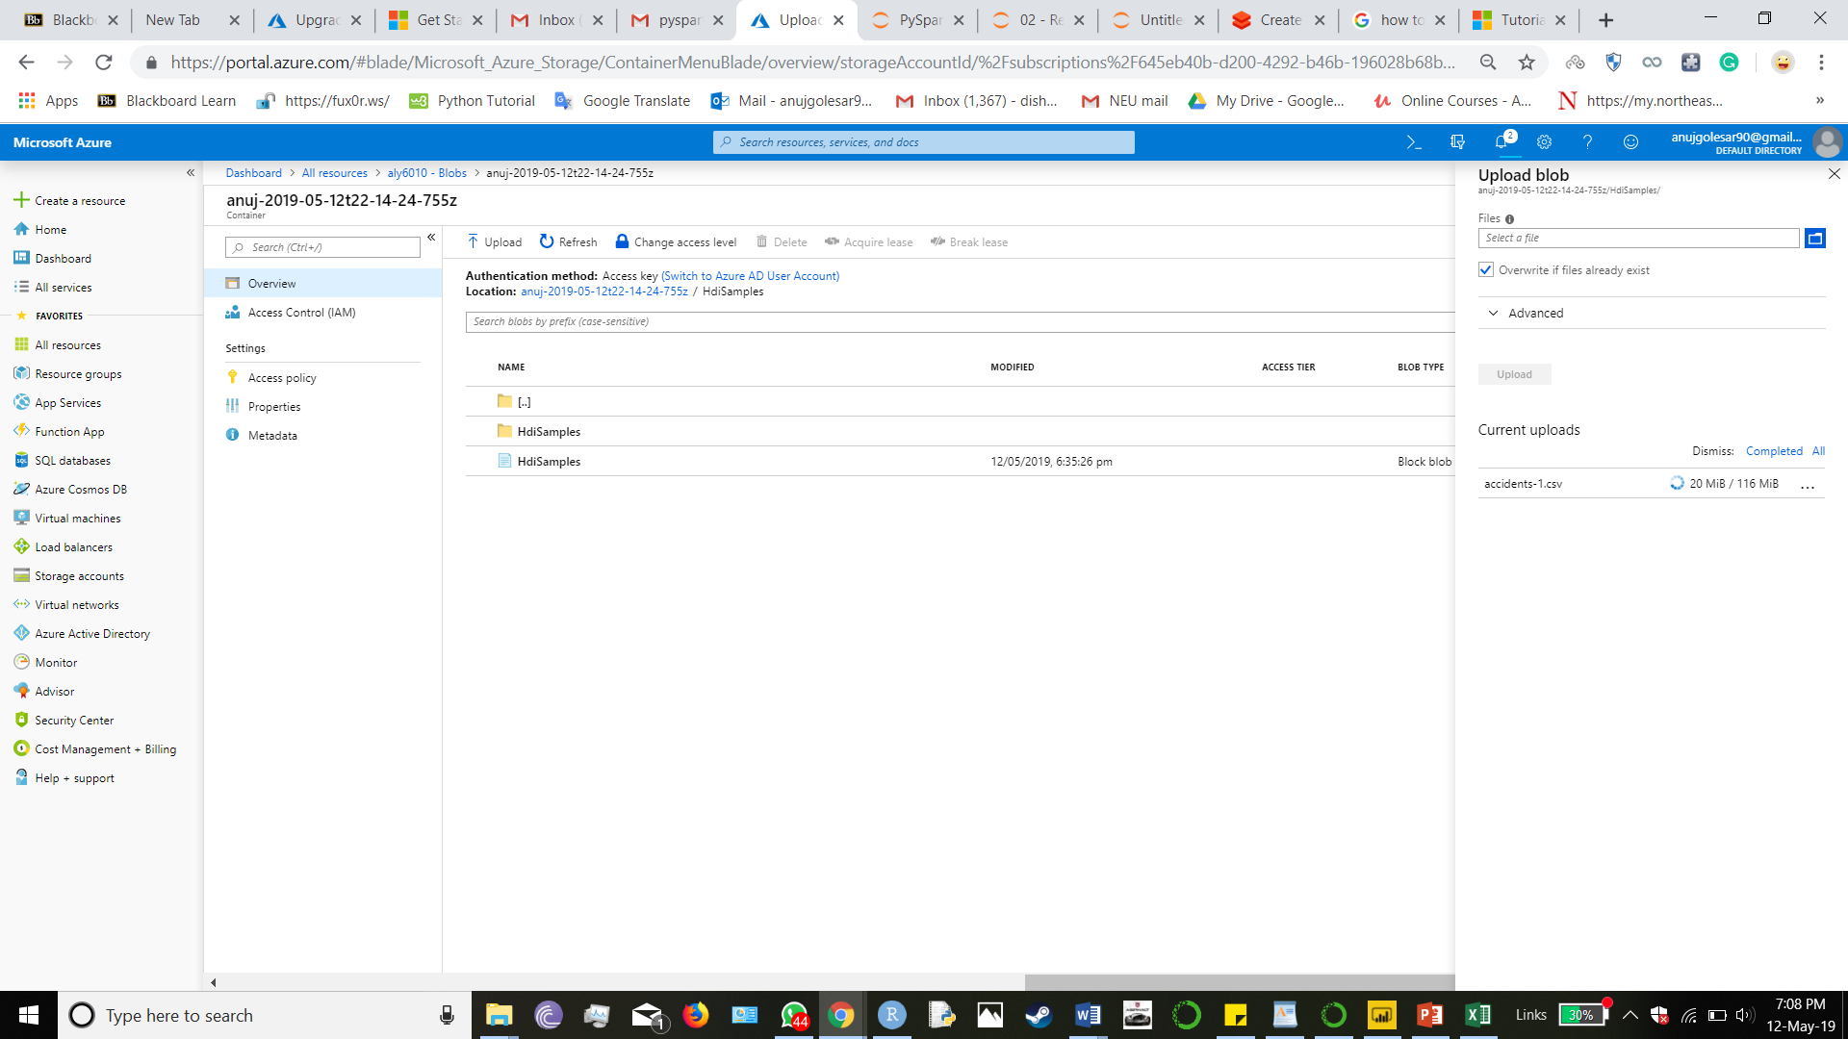

Now we have uploaded the file that we want to work on :

Now go to the HDInsight cluster and click on jupyter notebook

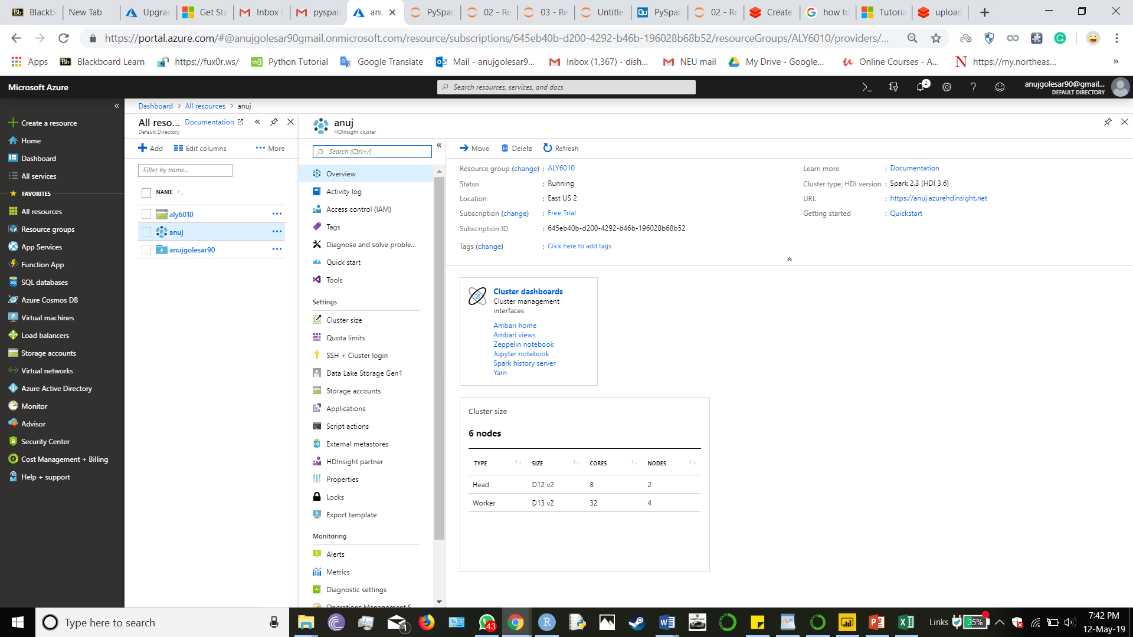

This will open an jupyter notebook in browser

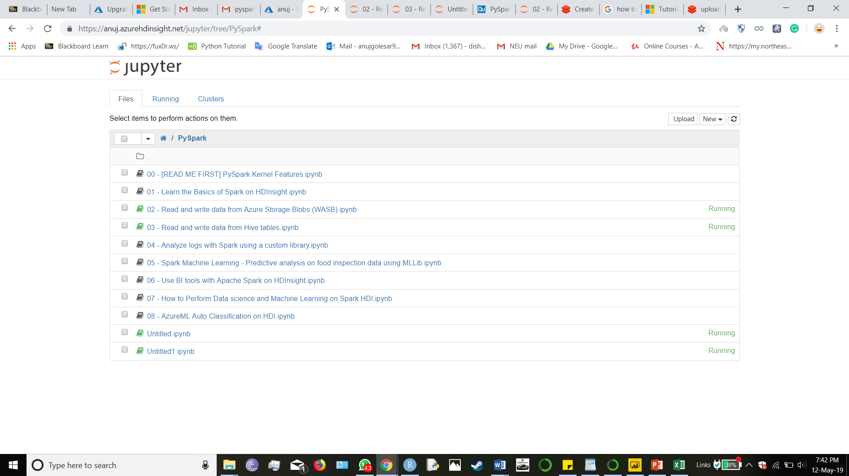

Click on NEW > pyspark

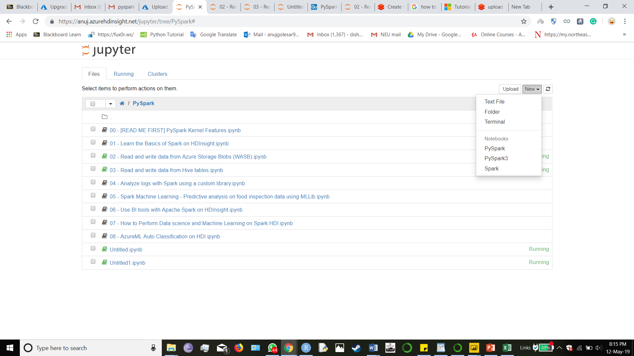

And u can start working on separate pyspark notebook as follows :

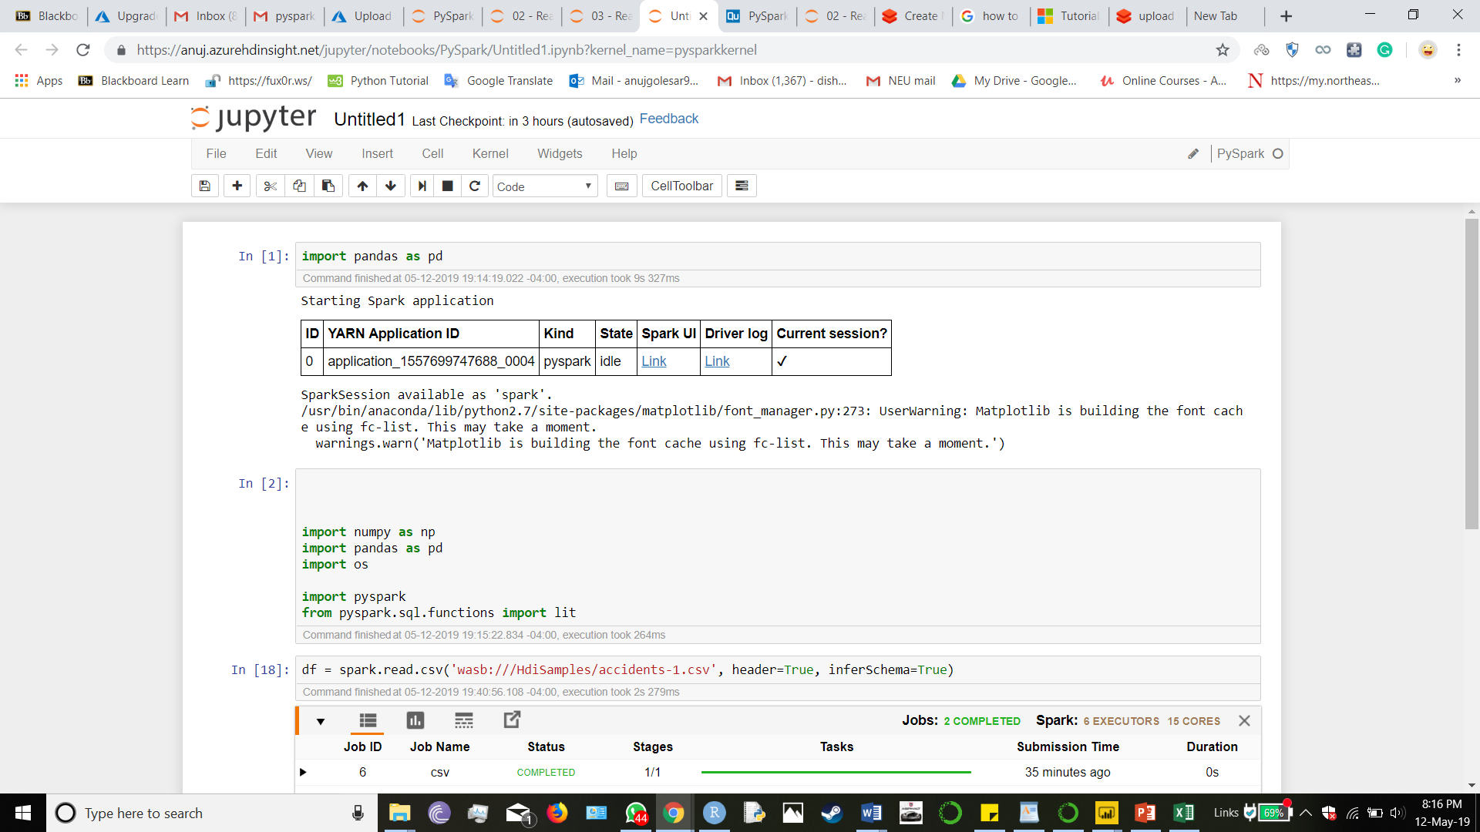

The below snap shop shows the execution of the pyspark code.

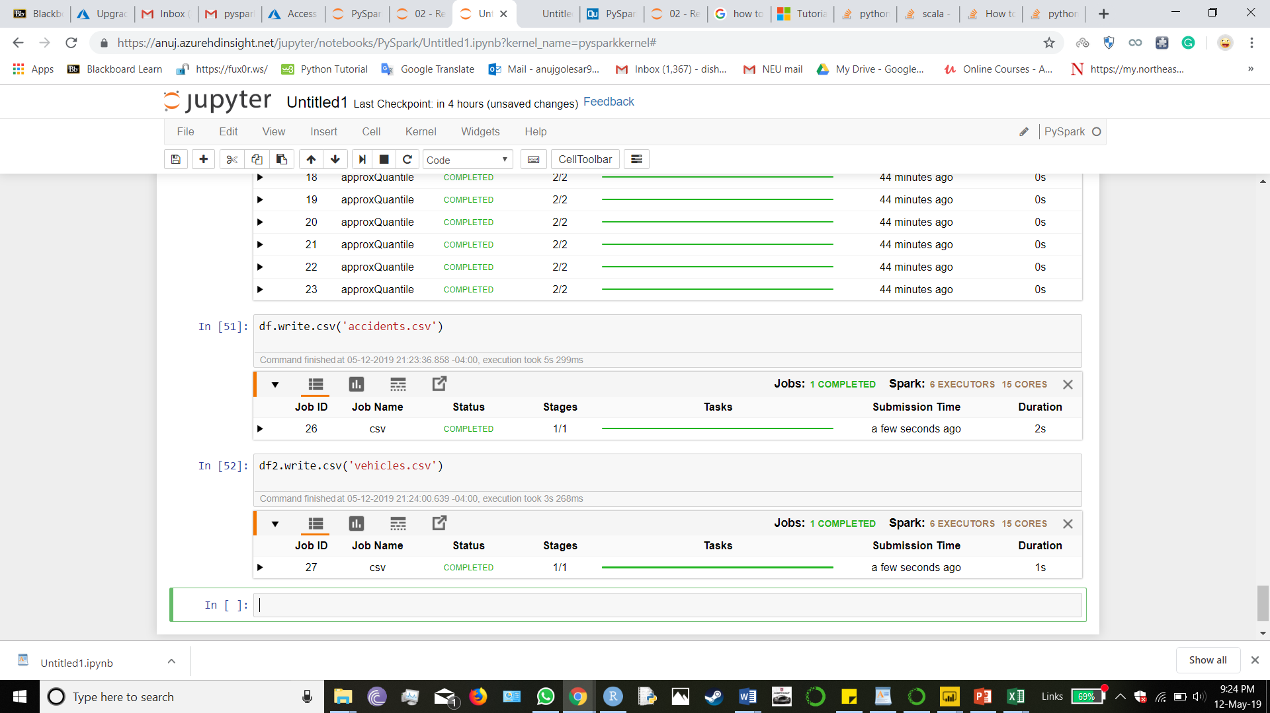

The next step is to connect the Power BI to the Microsoft Azure so as to access the data

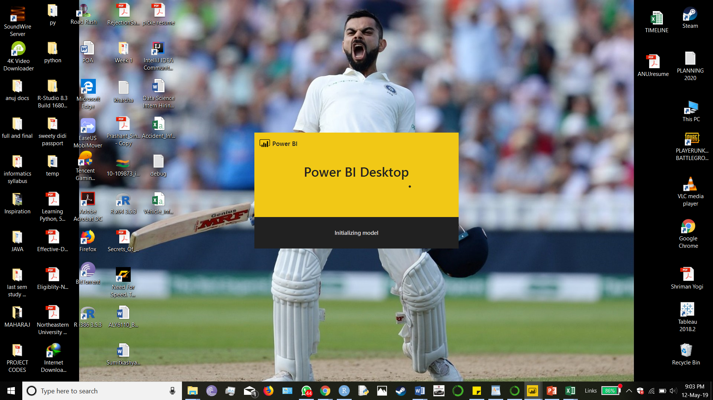

Loading the Power BI on the PC

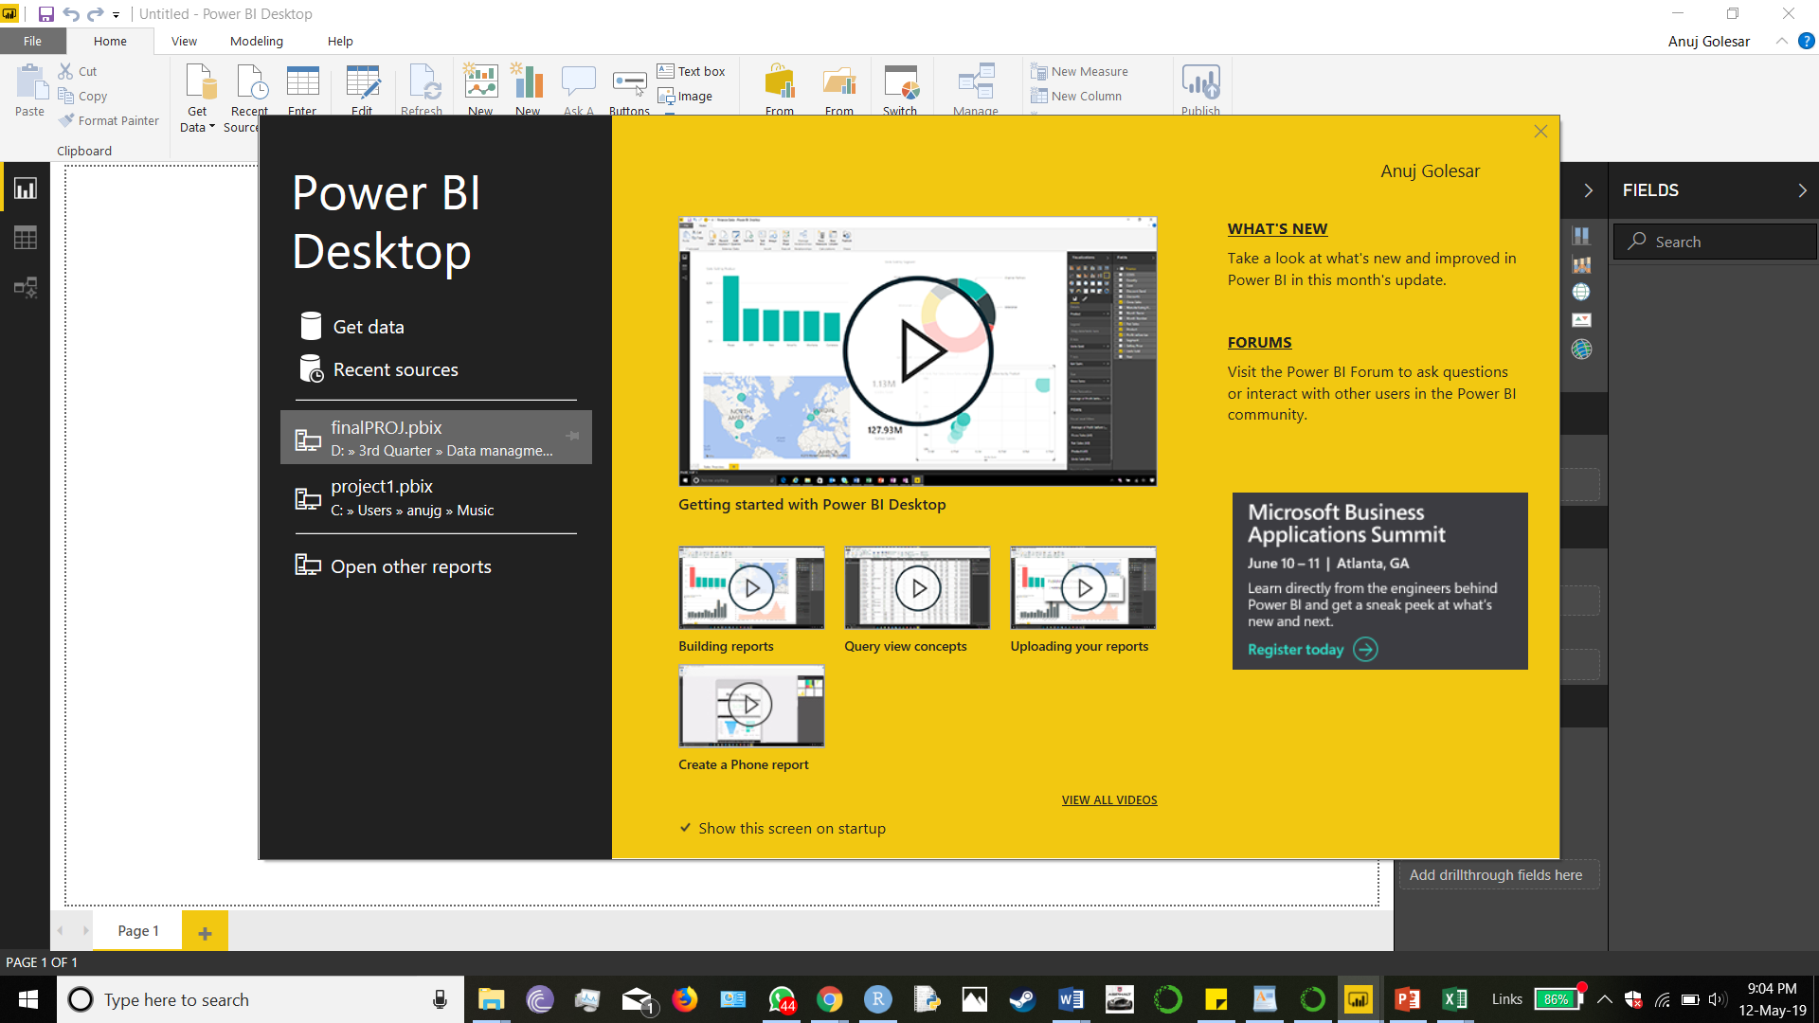

So as to load the data we click on Get data and click on Azure , and then click on Azure data storage.

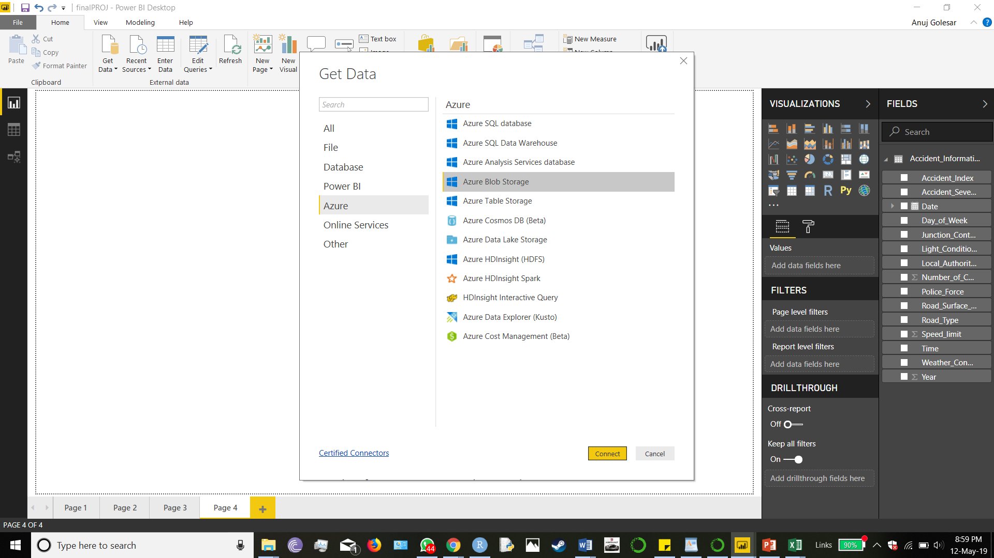

Enter the account name for Azure Blob Storage and click OK and enter the key URL for the connection.

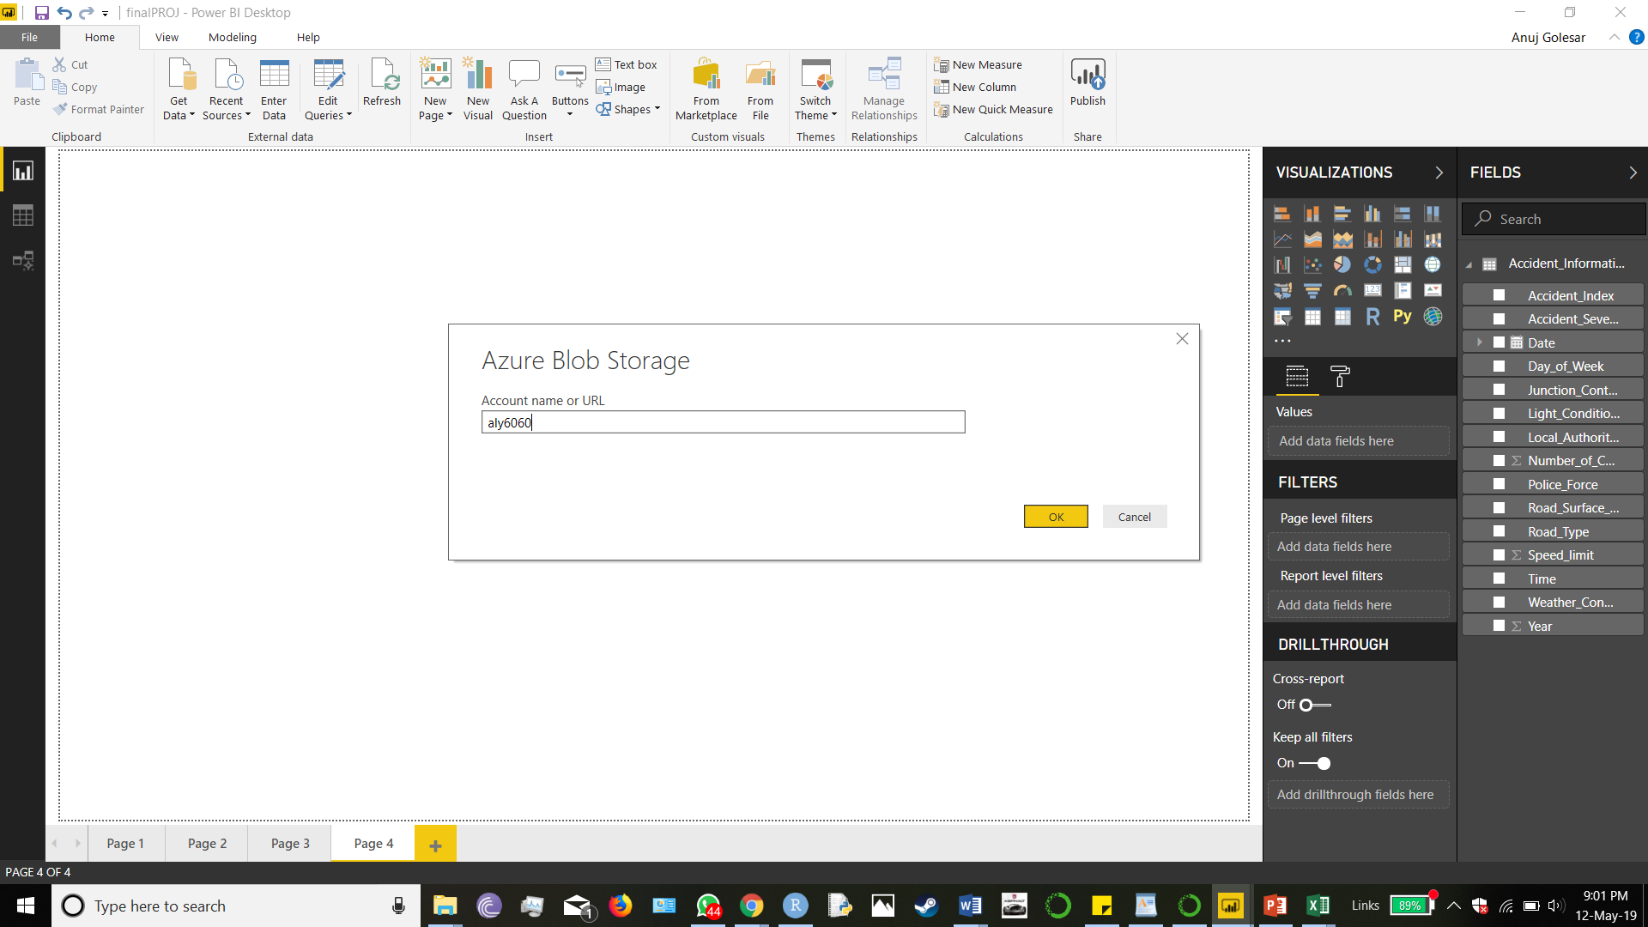

Now, the connection is established the all the all the files that are stored on the Blob storage are visible click on the load button

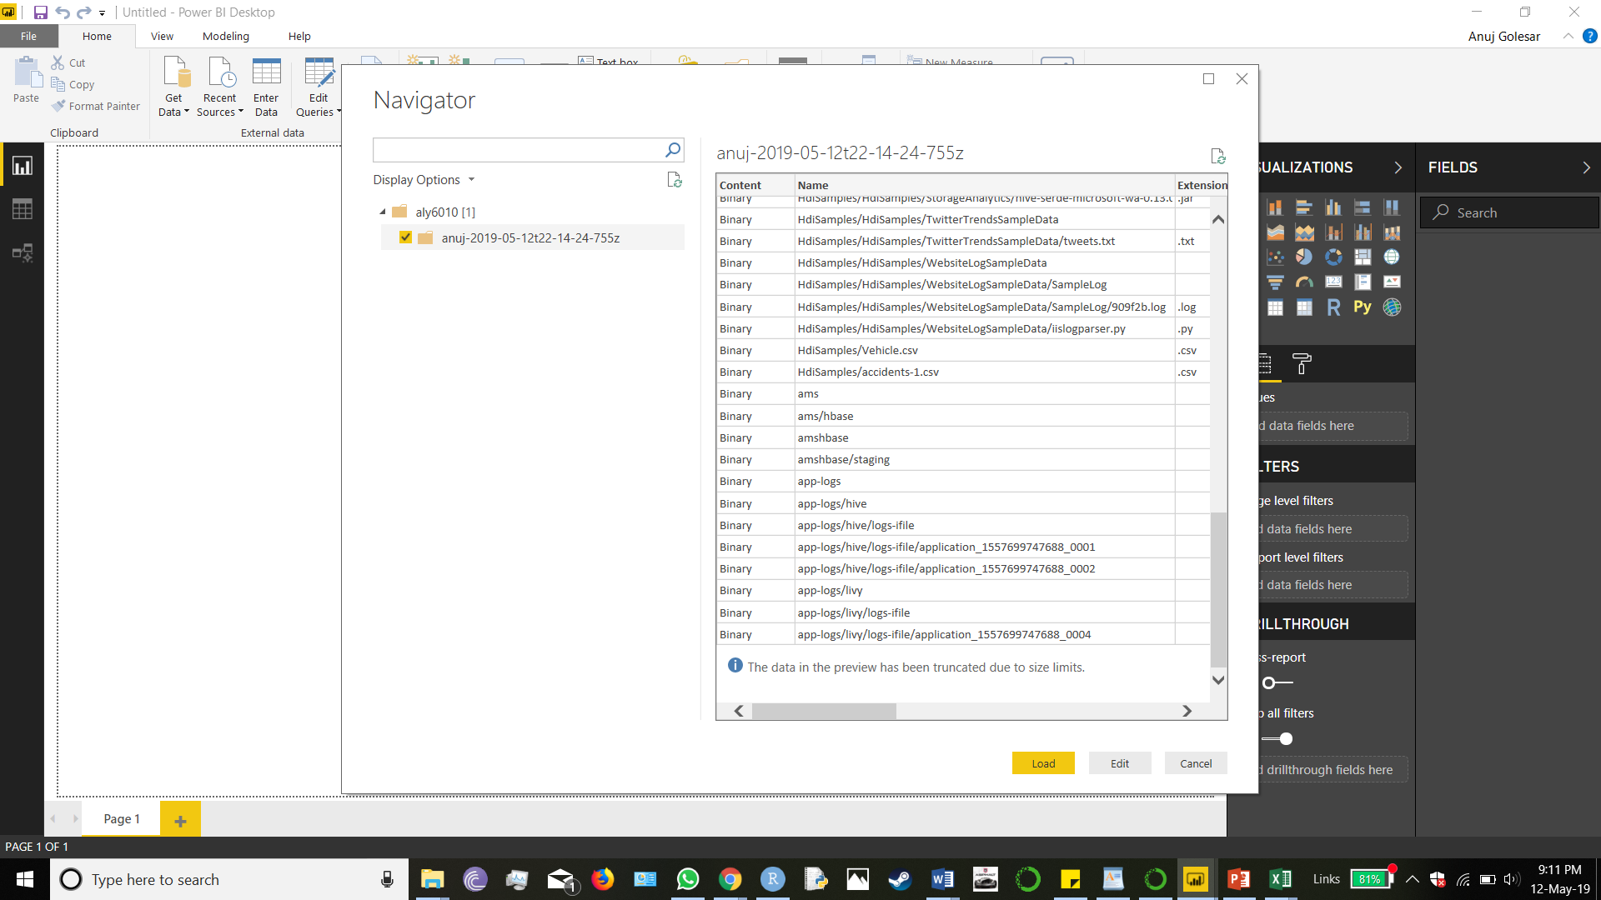

The files from the Blob Storage are loading for Data visualization.

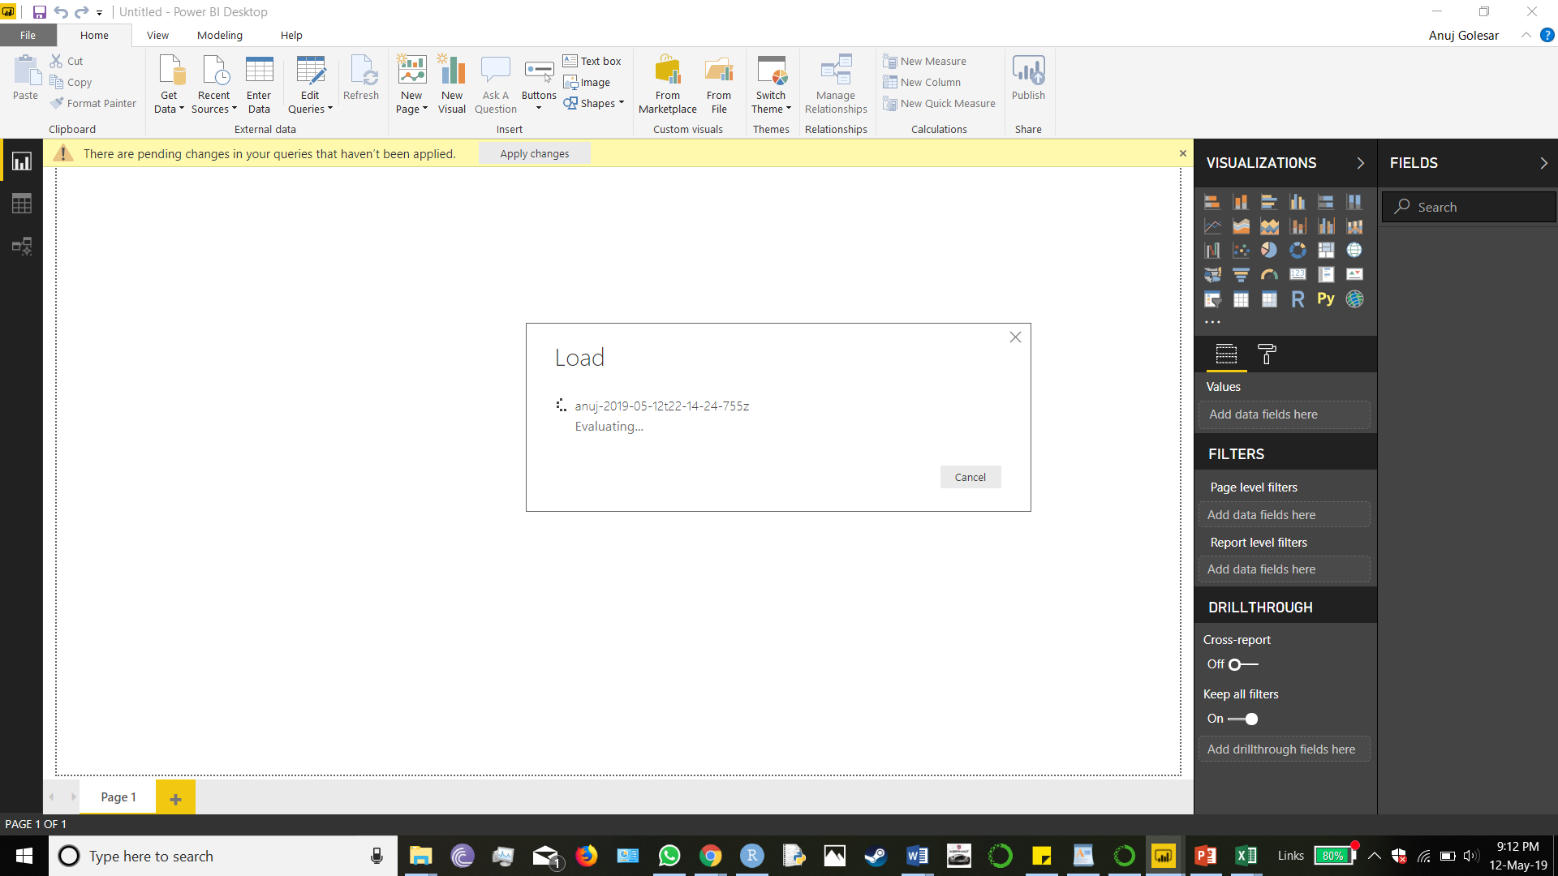

Data is now ready for visualization, we draw the following insights for the data

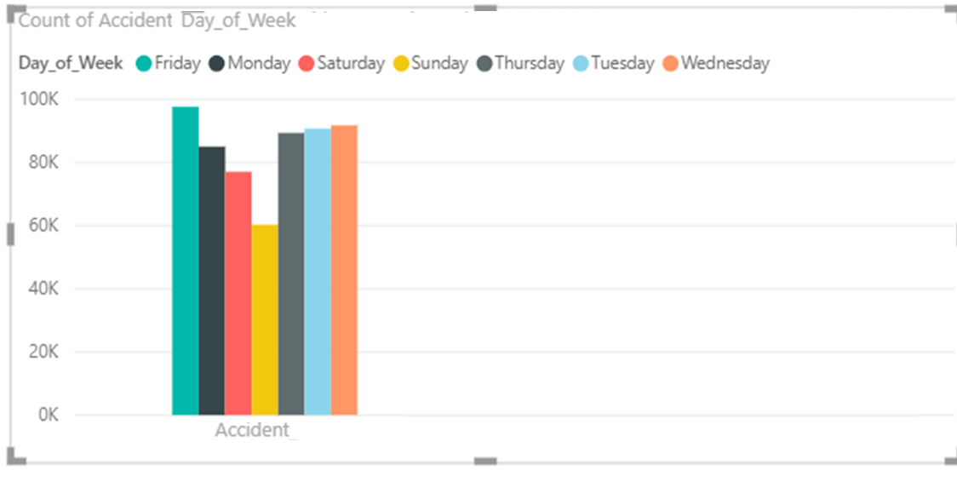

The above graph is the histogram of counts of accidents occurred on week days . The trend shows that there are highest number of accidents on Friday between 4 PM to 6 PM and lowest number of accidents on Sunday . This helps us to analyze the accidents occurring in a week , so as we can see that there are highest number of accidents on Friday and quite a few number of accidents on Tuesday , Wednesday .We can suggest local patrolling department to be more active on those days and hours and encourage drivers to be more active in observed time frame found out to be accident prone. Also, this can help the pedestrians to plan their outings.

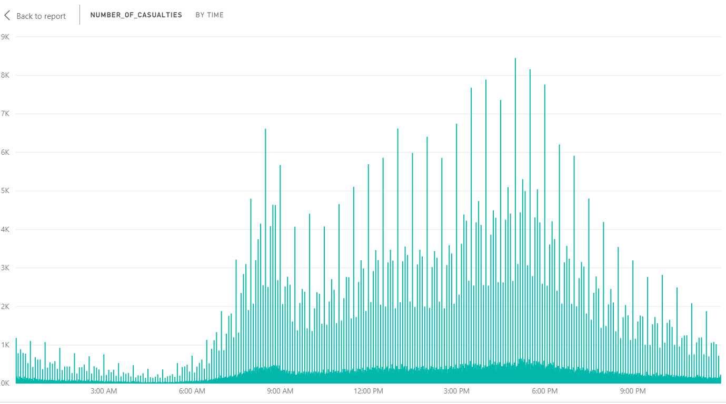

The above graph is comparison of accident severity over the period of one day. We can observe accidents occur between 8AM to 9:30 AM and the next peak time is 3:30 PM to 8PM. This is usually the peak time when citizens travel and most of the population is out of their houses.

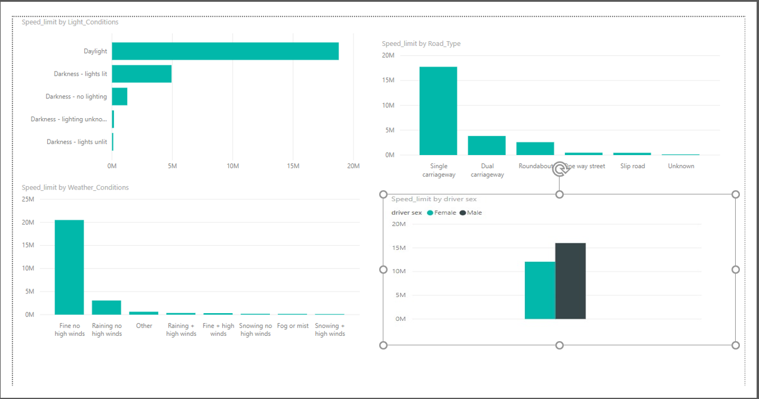

The above plots show the speed limits on different parameters like road conditions, light conditions, road type, weather condition and gender. The above bar plots are self-explanatory as we can see the first graph is the weather condition, most of the vehicles are out in day light hence speeds are observed to be higher in daylight as comparatively in the dark. Depending on the road type the highest speed of vehicles is found on single carriage roads. Also. when the weather is good, we can expect the speed of vehicles is high. Male drivers are comparatively driver on high speed as females in United Kingdom.

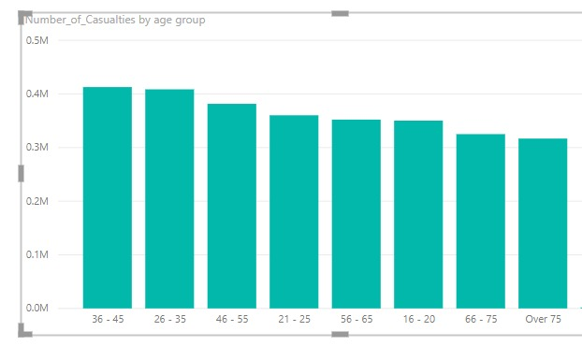

The above graph explains the age group and the accident occurred. The highest number of accidents occur in the 36-45 age and 26-35 groups. This shows that the young and working age groups are more prone to get into accidents and needs to be more active while they are commuting on their way.

CONCLUSION:

In this project we learned about Big Data tools. The importance of the processing power of the system and parallel processing of the data. While working on project we got to learn about installation process of different Big data tools. In our project we derived the important insights which answers crucial business questions and help local facilities to manage their resources efficiently and avoid accidents

REFERENCES:

#### [1]<https://www.qubole.com/resources/pyspark-cheatsheet/>

#### [2]DATASET:<https://www.kaggle.com/danofer/uk-accidents-aggregations/data>

#### [3]<https://pandas.pydata.org/pandas-docs/stable/reference/api/pandas.DataFrame.drop.html>